



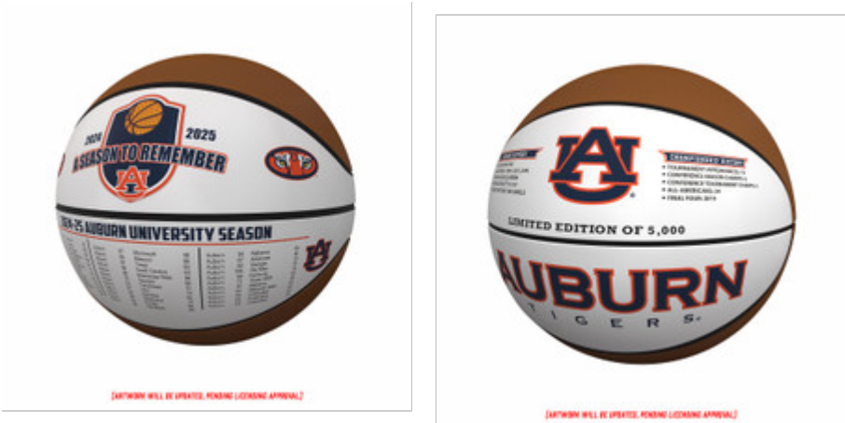
Auburn Tigers "Season to Remember" Exclusive Basketball

Limited Edition of 5,000

*Each basketball will come with an individually numbered
Certificate of Authenticity!

(anticipated to ship in Summer 2025)

This Special Gift

TO:

FROM:

