Happy Birthday!
To:

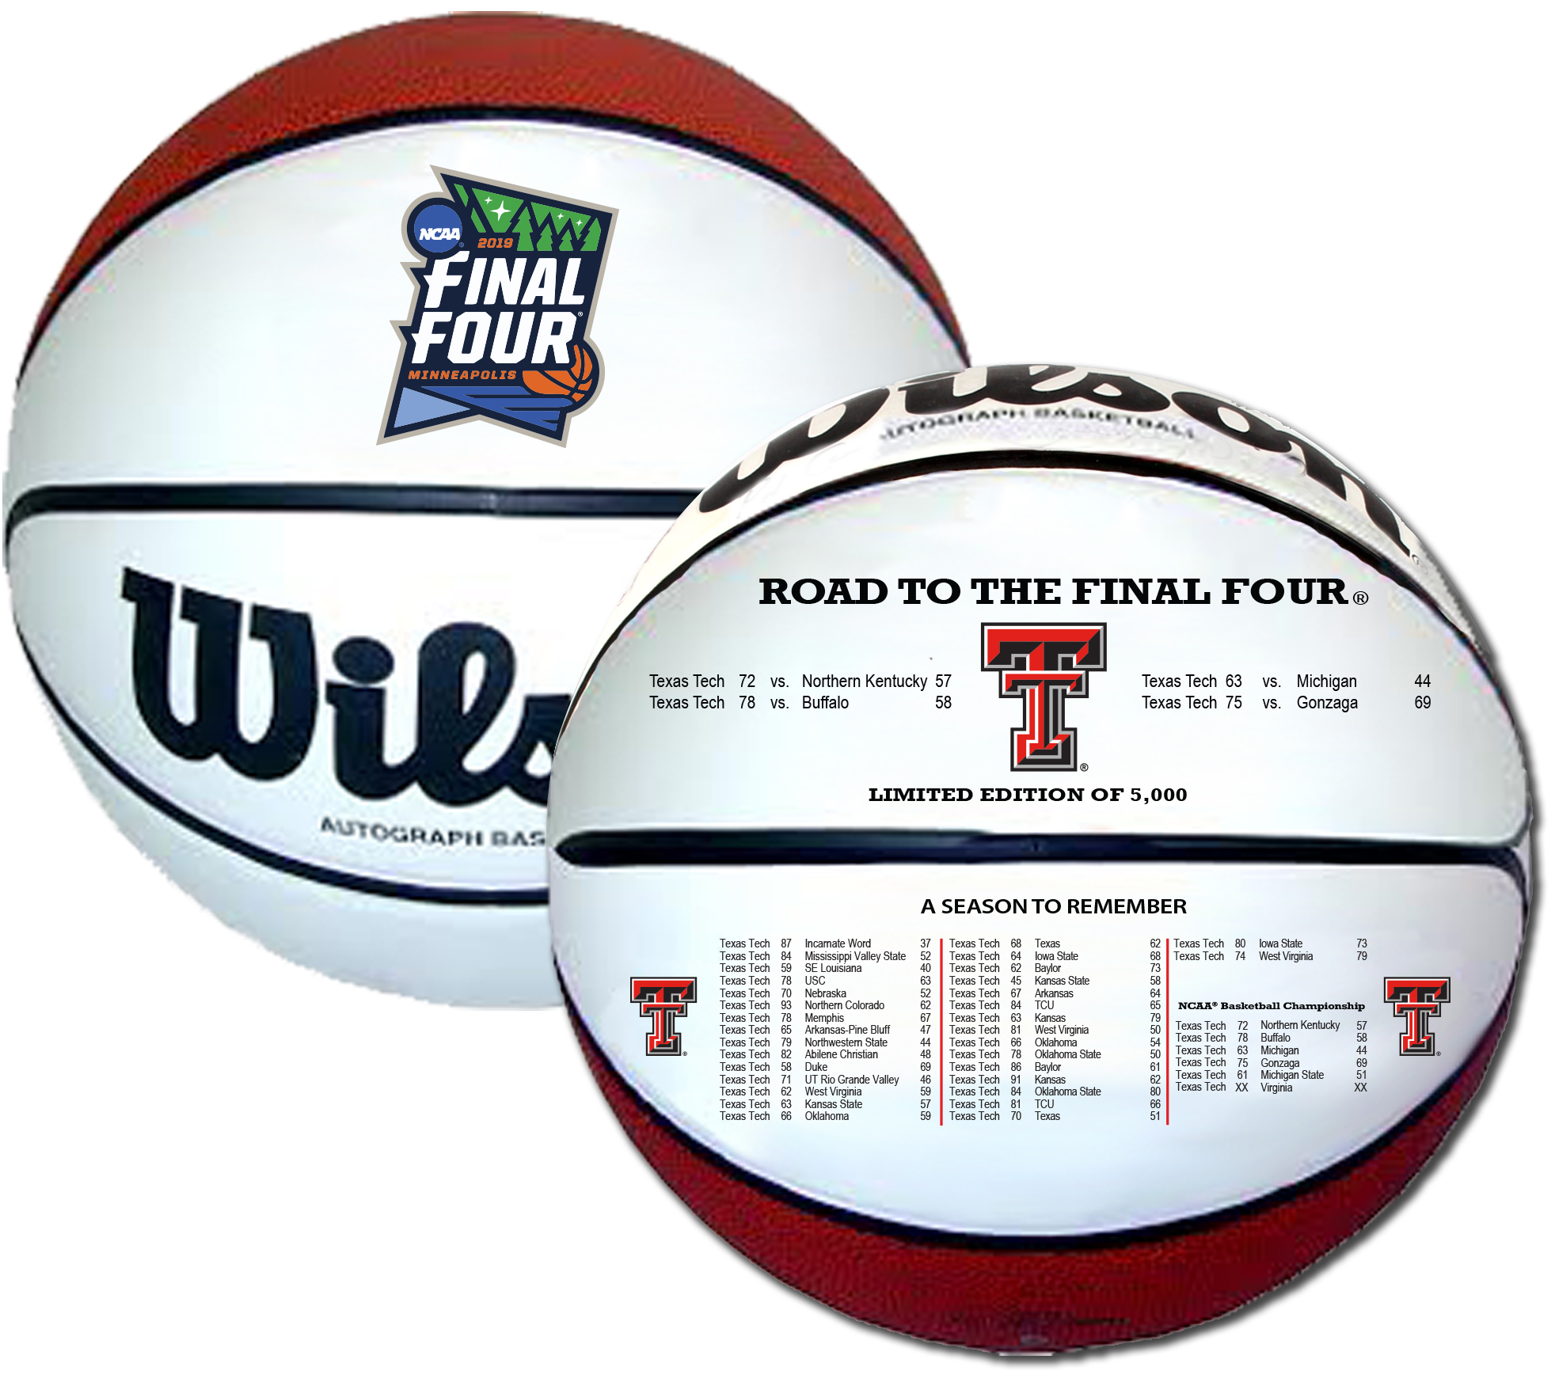

My gift to you is this:
Texas Tech Final Four,

Fully Embossed, Wilson Basketball
Limited Edition of 5,000
*shipping June 2019

From:

