


My Gift to You:

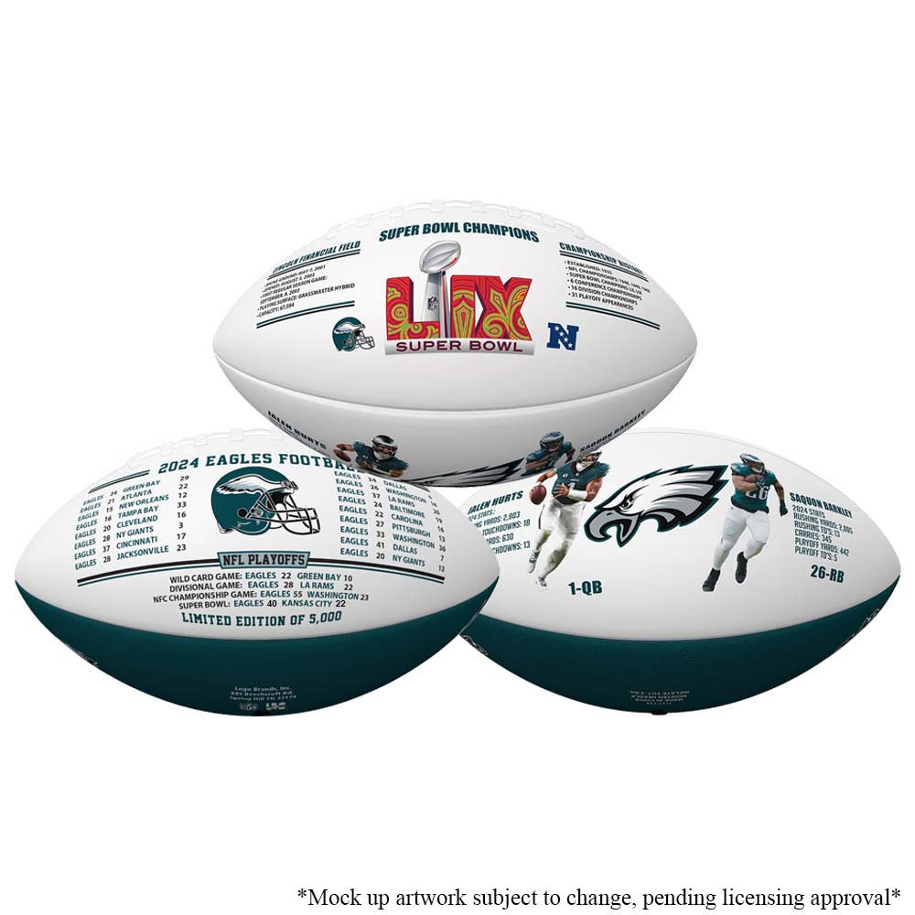

Philadelphia Eagles Super Bowl LIX Champions Exclusive Limited Edition Football

Limited Edition of 5,000
*Each football will come with an individually numbered
Certificate of Authenticity!

(Anticipated to ship Late April 2025)

TO:

FROM:

