Happy Birthday!
To:

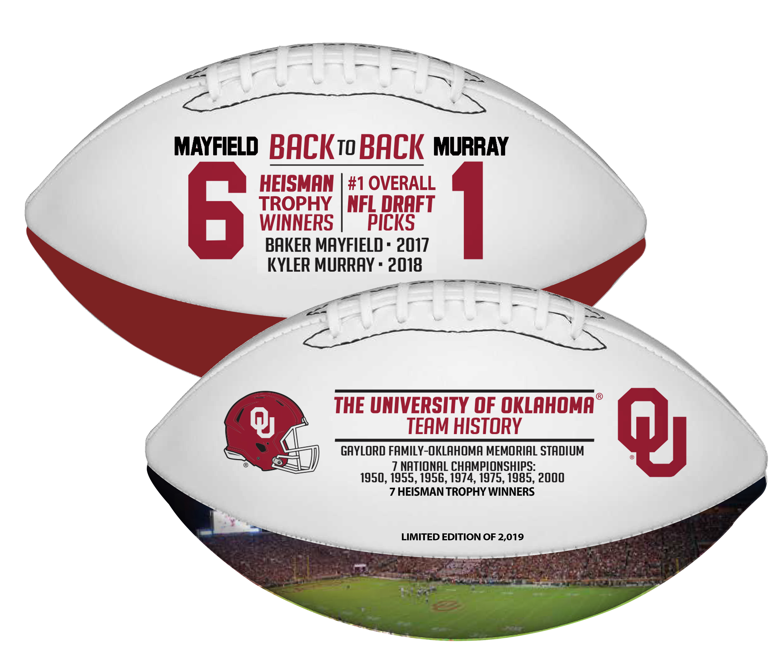

My gift to you is this:
Oklahoma Sooners Back to Back Heisman & #1 Draft Picks Football
Limited Edition of 2,019
*shipping November 2019

From:

