Happy Father’s Day!
To:

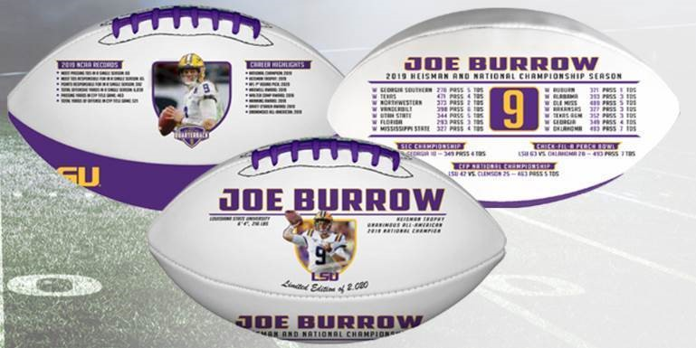

My gift to you is this:
Joe Burrow, LSU Tigers, Exclusive, Embossed Commemorative Football
Limited Edition of 2,020
*shipping Summer/Fall 2020

From:

