Happy Father’s Day!
To:

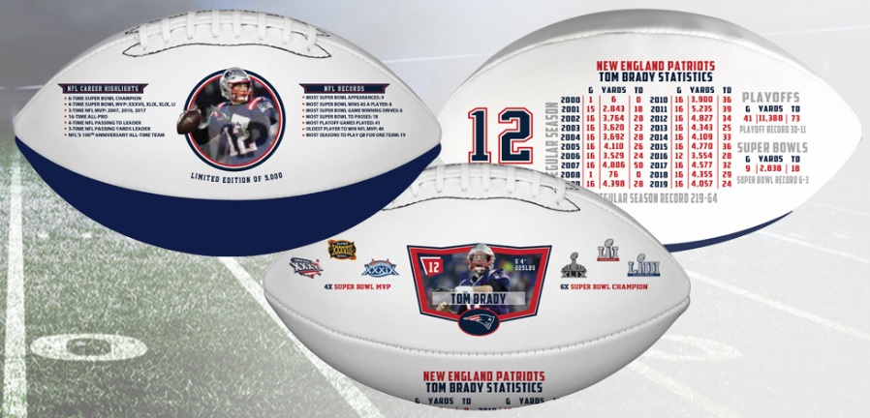

My gift to you is this:
Tom Brady New England Patriots, Exclusive, Embossed Career Football
Limited Edition of 2,020
*shipping Summer/Fall 2020

From:

