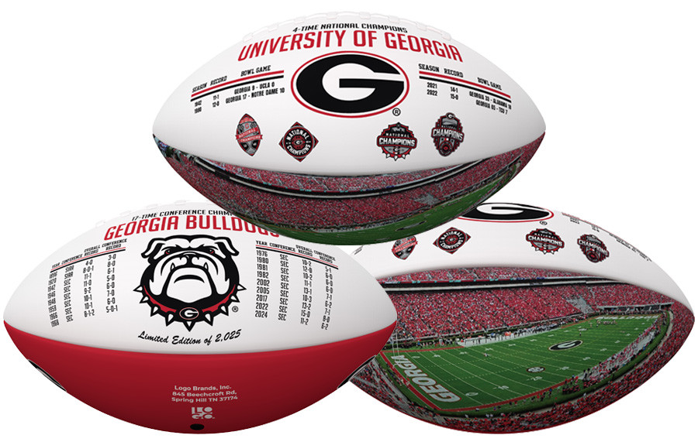




A SPECIAL GIFT FOR:
Georgia Bulldogs
“Championship History”
Exclusive Football
LIMITED EDITION OF 2,025

*EACH FOOTBALL WILL COME WITH AN INDIVIDUALLY NUMBERED CERTIICATE OF AUTHENTICITY

