
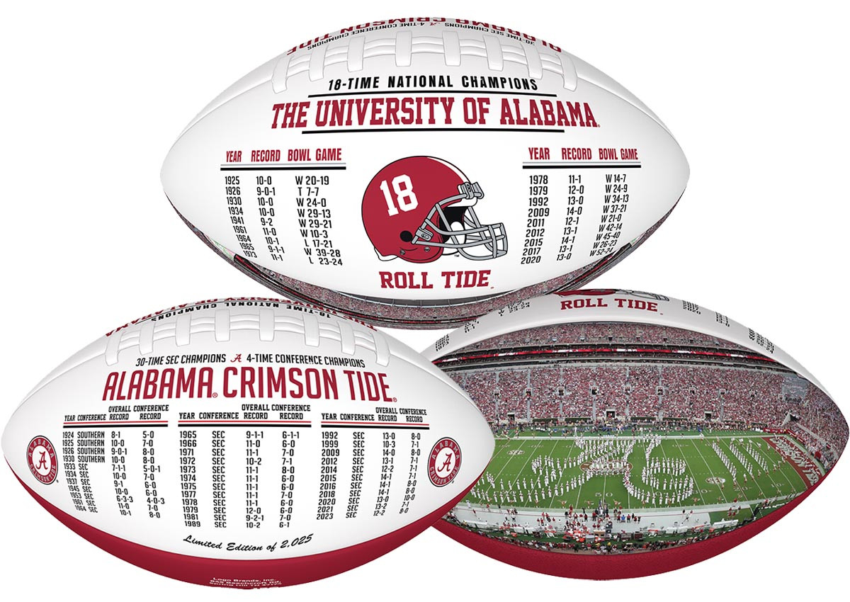



A SPECIAL GIFT FOR:
Alabama Crimson Tide
“Crimson Legacy”
Exclusive Football
LIMITED EDITION OF 2,025

*EACH FOOTBALL WILL COME WITH AN INDIVIDUALLY NUMBERED CERTIICATE OF AUTHENTICITY

