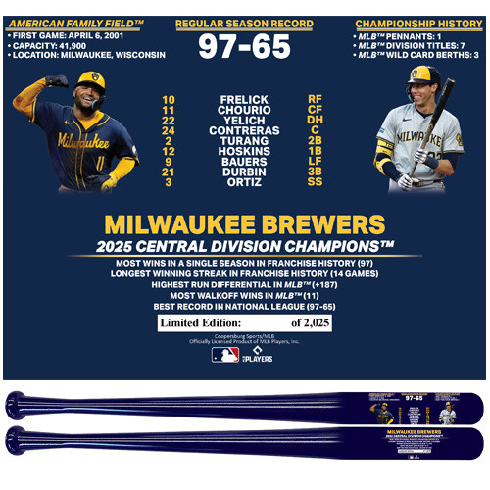




A SPECIAL GIFT FOR:
Milwaukee Brewers
Franchise Record Season
Exclusive Bat
LIMITED EDITION OF 2,025

*EACH BAT WILL COME WITH AN INDIVIDUALLY NUMBERED CERTIICATE OF AUTHENTICITY

