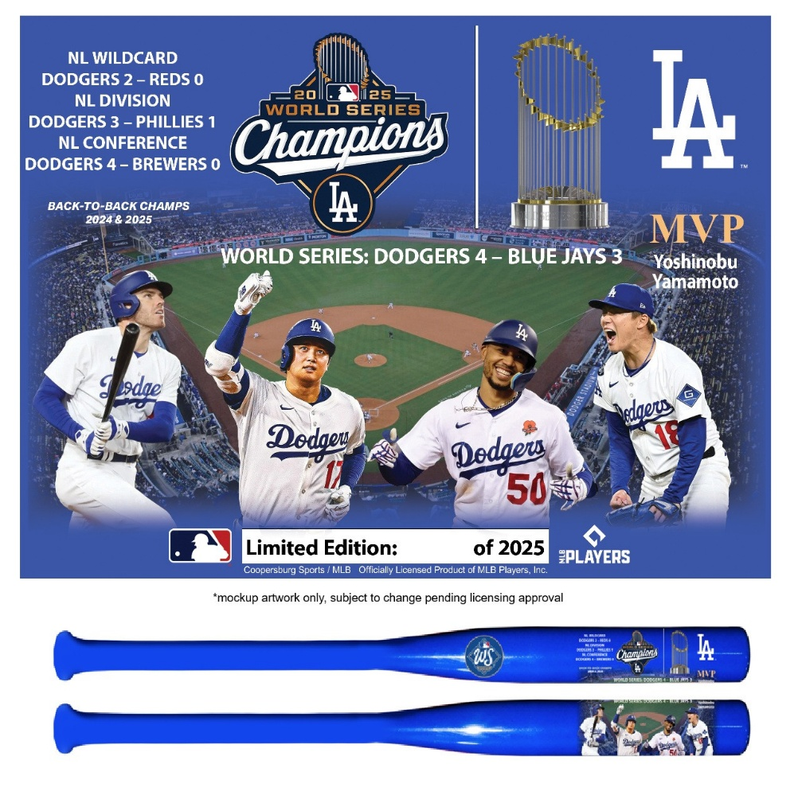




A SPECIAL GIFT FOR:
LA Dodgers
2025 World Series Champions
Exclusive Bat
LIMITED EDITION OF 2,025

*EACH BAT WILL COME WITH AN INDIVIDUALLY NUMBERED CERTIICATE OF AUTHENTICITY

